NOTICE OF ACCREDITATION ACTIONS
ACCE Midyear Conference
Irving, TX
February 17, 2023

The Council for Higher Education Accreditation (CHEA) requires that member programmatic accrediting agencies are to notify the public of accreditation decisions and the basis for such decisions. Within 30 business days after each board meeting in which accreditation decisions are completed, the American Council for Construction Education meets this requirement by publishing a notice of their accreditation actions on its website ACCE-HQ.org and distribution of the information in ACCE’s periodic email newsletter.
At its meeting on February 17, 2023, ACCE took the following actions regarding Programs in Construction Management related degrees at the Associate Degree, Bachelor’s Degree, and Master’s Degree within the institutions listed below.
Renewal of Accreditation
Programs in this category have completed a Self-Evaluation Study report and on-site evaluation. The term for renewal of accreditation is up to seven (7) years. For details of the accreditation for each Program, click on the link for the Degree Program or the link on the Accreditation Action line.
Ball State University
Department Construction Management and Interior Design
BS Degree in Construction Management
Muncie, IN 47306
Accreditation Action: Renewal of Accreditation for seven years
Expiration: February 28, 2030
Colorado State University
College of Health and Human Sciences
BS Degree in Construction Management
Fort Collins, CO 80523
Accreditation Action: Renewal of Accreditation for seven years Expiration: February 28, 2030
Eastern Michigan University
School of Engineering Technology
BS Degree in Construction Management
Ypsilanti, MI 48197
Accreditation Action: Renewal of Accreditation for seven years
Expiration: February 28, 2030

Florida Gulf Coast University
U.A. Whitaker College of Engineering
BS Degree in Construction Management
Fort Myers, FL 33965
Accreditation Action: Initial Accreditation for seven years
Expiration: February 28, 2030
Johnson County Community College  AAS Degree in Construction Management Technology  Overland Park, KS 66210  Accreditation Action: Initial Accreditation for seven years  Expiration: February 28, 2030 | 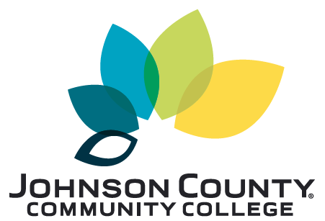
Kent State University
College of Architecture and Environment Design
BS Degree in Construction Management
Kent, Ohio, 44242-0001
Accreditation Action: Renewal of Accreditation for seven years
Expiration: February 28, 2030
Louisiana State University
College of Engineering
BS Degree in Construction Management
Baton Rouge, LA 70822
Accreditation Action: Renewal of Accreditation for seven years
Expiration: July 31, 2030
For additional information regarding ACCE’s accreditation procedures and the accredited programs, please visit the ACCE-HQ.org web site.

